PROJECT REPORT

On

**“ Car Showroom Management system ”**

***Submitted By:***

ASHWINI ANIL MALVI(CS23051)

**Guided By:-**

Mr. Ratnesh K. Choudhary



# DEPARTMENT OF FIRST YEAR ENGINEERING

**S. B. JAIN INSTITUTE OF TECHNOLOGY MANAGEMENT AND RESEARCH, NAGPUR.**

**2023-2024**

**S.B.J.I.T.M.R Nagpur 2024**

**CONTENTS**

1. Introduction (Project Details) ............................................................................01
2. Major Library and Functions…………………………………………………..03
3. Source Code (Program)......................................................................................04
4. Result (Output)....................................................................................................12
5. Conclusion…………………...............................................................................17
6. References………………………………………………………………………17 **Introduction (Project Details):**

This report is an introduction to the Car showroom management system project in ‘C’ programming. The program serves as a simple automotive showroom management system, which allow users to perform various tasks related to car models, client information, and financial transactions. Anybody , who doesn’t know even the basic of management system project in ‘C' ,will be certainly able to understand and gain the great knowledge from this report .The core theme of the report focus on the development of management system project in C language.

Features:

**1.Car Model Information**:

* Users can insert details of car models, including brand, model number, color, fuel type, car average, and price.
* The information is saved in a file named "model.txt."

**2.Display Car Models:**

* It displays a nicely formatted information of car.
* Users can view a list of car models along with their details.
* The program reads the information from the "model.txt" file and displays it to the user.

3. **Search Car Models:**

* Users can search for car models based on the brand name.
* The program reads the information from the "model.txt" file and displays details for the specified brand.

4. **Client Information:**

* Showroom owner can add the details of clients. And can access transaction detail.

including registration number, name, phone number, email, model bought, date of purchase, and date of delivery.

* The client information is saved in a file named "client.txt."

5**. Car Services:**

* You can find the information about the accessories and maintance services provided along with the car model
* Users can explore two categories of car services: maintenance and accessories.they can choose which service they want to apply for their car model.
* The program provides details and prices for various maintenance services and accessories.

6. **Financial Transaction:**

* Users can record financial transactions related to clients, specifying whether it's a deposit or withdrawal.
* Transaction details, including type, client name, and amount, are saved in a file named "transactions.txt."

7. **Transaction History:**

* Users can view a summary of financial transactions or search for transactions based on type (deposit/withdraw).
* The program reads information from the "transactions.txt" file to display or search transaction details.

8. **Exit:**

- Users can choose to exit the program when they have completed their tasks

Users interact with the program by selecting options from the menu, entering relevant information, and reviewing the displayed results. The program utilizes file input-output operations to store and retrieve information from the files.

**Major Library and Functions:**

In This C program, I have used several standard C libraries and functions. Here are the major ones:

1. <**stdio.h> :**

Standard Input/Output functions. Used for reading input `scanf ` and printing output `printf 2. <**stdlib.h> :**

Standard Library functions. Used for memory allocation and other general-purpose functions.

1. **<string.h> :**

String functions. Used for string manipulation, such as comparing strings `strcmp`, copying strings `strcpy`, etc.

1. **<fopen> and <fclose>** **:**

Functions for file operations.`fopen` is used to open a file, and `fclose` is used to close it.

1. **<scanf > :**

Reads formatted input from the standard input or from a file.

1. **<printf>** :

Prints formatted output to the standard output or to a file.

7 **<getchar> :**

Reads a single character from the standard input.

1. **<strcmp> :**

Compares two strings and returns an integer indicating their lexicographical relationship.

1. **<while loop> :**

A control flow statement for repeating a block of statements while a given condition is true.

1. **<struct> :**

Defines a user-defined data type. Used to create structures such as `struct model`, `struct client`, `struct transaction` with multiple fields to store related information.

These libraries and functions provide the necessary tools to handle input/output, file operations, string manipulation, and structuring data using user-defined types. The program is organized into functions for modularity, and a loop is used to present a menu for user interaction.

**Source Code:**

#include<stdio.h>

#include<stdlib.h>

#include<string.h>

struct model { // model information char brand[30]; int model_number; char color[10]; float car_average; char fuel[10]; float price;

};

struct client { // client information int registration; char name[50]; int phone_number; char email[20]; char model_buy[10]; char dop[10]; char dod[10];

};

struct transaction { //money transaction char type[15]; // "Deposit" or "Withdraw" char c[30]; float amount;

};

struct model insert(struct model car) { // function to insert car information printf("\tModel Name:"); scanf("%s", &car.brand); printf("\tModel Number:"); scanf("%d", &car.model_number); printf("\tmodel colour:"); scanf("%s", &car.color); printf("\tcar average:"); scanf("%f", &car.car_average); printf("\ttype of fuel used in car:"); scanf("%s", &car.fuel); printf("\tprice of model(in lakh):"); scanf("%f", &car.price);

while (getchar() != '\n'); return car;

}

void save(struct model car) { // function to save model information FILE *file = fopen("model.txt", "a");

fprintf(file, "%s %d %s %f %s %f\n", car.brand, car.model_number, car.color, car.car_average, car.fuel, car.price);

fclose(file);

return;

}

void showdetail(struct model car) { // function to show details FILE *file = fopen("model.txt", "r");

while (fscanf(file, "%s %d %s %f %s %f", car.brand, &car.model_number, car.color,

&car.car_average, car.fuel, &car.price) != EOF) { printf("Brand: %s\n", car.brand);

printf("Model Number: %d\n", car.model_number); printf("Color: %s\n", car.color);

printf("Car Average: %.2f\n", car.car_average);

printf("Fuel: %s\n", car.fuel); printf("Price: %.2f\n", car.price);

printf("--------------------------------------------------------------------------------\n\n");

} fclose(file); return; }

void searchModel(char searchBrand[]) { // function to search for a model by brand struct model car;

printf("Enter the brand to search: ");

scanf("%s", searchBrand);

FILE *file = fopen("C:\\Users\\Madhura\\OneDrive\\Desktop\\model.txt", "r"); int found = 0;

while(fscanf(file,"%s%d%s%f%s%f",car.brand,&car.model_number,car.color,

&car.car_average, car.fuel, &car.price) != EOF) { if (strcmp(car.brand,searchBrand) == 0) { found = 1;

printf("\nBrand: %s\n",car.brand);

printf("Model Number: %d\n", car.model_number); printf("Color: %s\n", car.color); printf("Car Average: %.2f\n", car.car_average); printf("Fuel: %s\n", car.fuel);

printf("Price: %.2f lakh\n\n", car.price);

} }

fclose(file);

if (!found) {

printf("No model found with brand: %s\n", searchBrand);

} return; }

void client(struct client person){ //client details

printf("registration number of client:"); scanf("%d",&person.registration); printf("client Name:"); scanf("%s",person.name); printf("Phone Number:"); scanf("%d",&person.phone_number);

printf("email address:"); scanf("%s",&person.email); printf("model bought:");

scanf("%s",&person.model_buy);

printf("Date of car purchase:"); scanf("%s",&person.dop); printf("Date of car dilevery:"); scanf("%s",&person.dod);

return;

}

void saveclient(struct client person){ //show client information FILE *file=fopen("client.txt","a"); fprintf(file,"%d",person.registration); fprintf(file,"%s",person.name); fprintf(file,"%d",person.phone_number); fprintf(file,"%s",person.email); fprintf(file,"%s",person.model_buy); fprintf(file,"%s",person.dop); fprintf(file,"%s",person.dod);

fclose(file); return;

}

void addtransaction(struct transaction trans){ //add transaction printf("Enter transaction type (Deposit/Withdraw): ");

scanf("%s", &trans.type); printf("client name:"); scanf("%s",&trans.c); printf("Enter amount:"); scanf("%f", &trans.amount); while (getchar() != '\n');

} void saveTransaction(struct transaction trans) { //save money transaction FILE*file= fopen("C:\\Users\\Madhura\\OneDrive\\Desktop\\transactions.txt", "a"); fprintf(file, "%s %s%f\n",trans.type,trans.c,trans.amount); fclose(file); return; }

void showtransactiondetail(struct transaction trans) { //function to show transactioon details FILE*file = fopen("C:\\Users\\Madhura\\OneDrive\\Desktop\\transaction.txt", "r"); while (fscanf(file, "%s %s%f\n", trans.type,trans.c,&trans.amount) != EOF) { printf("transaction type: %s\n",trans.type); printf("name of client: %s\n",trans.c); printf("amount: %.2f\n", trans.amount);

printf("--------------------------------------------------------------------------\n\n");

} fclose(file);

return; }

// function to search transaction history based on user input void searchTransactionHistory(char searchType[]) {

struct transaction trans;

printf("Enter the transaction type to search (Deposit/Withdraw): "); scanf("%s", searchType);

FILE*file=fopen("C:\\Users\\Madhura\\OneDrive\\Desktop\\transactions.txt", "r"); int found = 0;

while (fscanf(file, "%s %s %f", trans.type, trans.c, &trans.amount) != EOF) { if (strcmp(trans.type, searchType) == 0) {

found = 1; printf("Type: %s\n",trans.type); printf("Name of client:%s",trans.c);

printf("Amount: %.2f\n",trans.amount);

printf("-------------------------------------------------------------------------------\n\n"); }

}

fclose(file); return;

}

// Function to choose services for accessories and maintenance void chooseServices(int *servicesChoice) { printf("Do you want services?\n"); printf("Enter [1]: Yes\n"); printf("Enter [2]: No\n"); printf("Enter your choice: "); scanf("%d", servicesChoice);

}

// main function int main() { struct model car = {0}; struct client person; struct transaction trans; char searchBrand[30]; char searchType[30]; int serviceschoice,choice, ch,i, n; char service[50];

printf("----------------------------------------------------------------------------------------------------

--------------------\n");

printf("\t\t\t\t\t\t\tWELCOME TO \n\t\t\t\t\t\tABC AUTOMOTIVE SHOWROOM\n");

printf("---------------------------------------------------------------------------------------------------

---------------------"); do { printf("\n\t\t\t\twhat do you want to choose?\n"); printf("\t\t\t\tEnter [1]: Insert Car Models details\n"); printf("\t\t\t\tEnter [2]: car model list\n"); printf("\t\t\t\tEnter [3]: search car model\n"); printf("\t\t\t\tEnter [4]: Insert Client details\n"); printf("\t\t\t\tEnter [5]: Car services provided\n");

printf("\t\t\t\tEnter [6]: Choose services for accessories and maintenance\n"); printf("\t\t\t\tEnter [7]: way of transaction\n"); printf("\t\t\t\tEnter [8]: Record money transaction\n");

printf("\t\t\t\tEnter [9]: Exit\n"); printf("\t\t\t\tEnter your choice: "); scanf("%d", &choice); printf("--------------------------------------------------------------------------------\n\n");

switch (choice) { case 1:

printf("Number of car information to be inserted: "); scanf("%d", &n);

printf("Insert information about car %d-\n", i + 1); for (i = 0; i < n; i++) {

car = insert(car); save(car); printf("\n");

}

printf("------------------------------------------------------------------------------\n"); printf("------------------------------------------------------------------------------\n\n"); break; case 2: showdetail(car); printf("------------------------------------------------------------------------------- \n"); printf("------------------------------------------------------------------------------- \n\n"); break; case 3:

searchModel(searchBrand);

printf("--------------------------------------------------------------------------------\n"); printf("--------------------------------------------------------------------------------\n\n"); break; case 4:

client(person); saveclient(person); printf("-------------------------------------------------------------------------------- \n"); printf("--------------------------------------------------------------------------------\n\n"); break; case 5:

printf("Enter [1]: Maintenance of car\n"); printf("Enter [2]: Accessories for car models\n"); printf("What you want to know? "); scanf("%d", &serviceschoice); switch (serviceschoice) { case 1:

printf("\n\nchange oil and oil filter\t\t\t\t\t\t\t-\t650.00/-\n"); printf("replace all filters(air,fuel,PCV)\t\t\t\t\t\t-\t1330.00/-\n"); printf("lubricate chassls\t\t\t\t\t\t\t\t-\t475.00/-\n"); printf("check breaks and wheelbearing\t\t\t\t\t\t\t-\t115.00/-\n");

printf("check and adjust valves\t\t\t\t\t\t\t\t-\t275.00/-\n"); printf("check all belts including timing belt\t\t\t\t\t\t-\t90.00/-\n"); printf("check temperature for sysytem\t\t\t\t\t\t\t-\t100.00/-\n"); printf("replace plugs,points,cap and rotor\t\t\t\t\t\t-\t870.00/-\n"); printf("inspect cooling sysytem\t\t\t\t\t\t\t\t-\t90.00/-\n"); printf("check fir leaks\t\t\t\t\t\t\t\t\t-\t100.00/-\n"); printf("perform wheels rotation\t\t\t\t\t\t\t\t-\t125.00/-\n"); printf("--------------------------------------------------------------------------------\n"); printf("--------------------------------------------------------------------------------\n\n"); break;

case 2:

printf("\n\ngarnish on lower boot\t\t\t\t\t\t\t\t\t-\t2050/-\n"); printf("body mouldings\t\t\t\t\t\t\t\t\t\t-\t5370/-\n");

printf("door handels\t\t\t\t\t\t\t\t\t\t-\t1715/-\n");

printf("seat covers\t\t\t\t\t\t\t\t\t\t-\t299/-\n");

printf("floor mats\t\t\t\t\t\t\t\t\t\t-\t349/-\n"); printf("dashboard decorations\t\t\t\t\t\t\t\t\t-\t273/-\n");

printf("air fresheners\t\t\t\t\t\t\t\t\t\t-\t189/-\n");

printf("alloy wheels\t\t\t\t\t\t\t\t\t\t-\t500/-\n"); printf("--------------------------------------------------------------------------------\n"); printf("--------------------------------------------------------------------------------\n\n"); break;

} break; case 6:

chooseServices(&serviceschoice); if (serviceschoice == 1) {

printf("Enter which service you want to choose:"); scanf("%s", &service[50]);} else if (serviceschoice== 2) {

printf("You chose not to avail services.\n");

}else{

printf("Invalid choice for services.\n"); } printf("-------------------------------------------------------------------------------- \n"); printf("--------------------------------------------------------------------------------\n\n"); break;

case 7: addtransaction(trans); saveTransaction(trans); printf("--------------------------------------------------------------------------------\n"); printf("--------------------------------------------------------------------------------\n\n"); break; case 8:

printf("Enter [1]: show Transaction history.\n"); printf("Enter [2]: search Transaction history.\n"); printf("Enter your choice:"); scanf("%d", &ch);

switch (ch) { case 1:

showtransactiondetail(trans); break;

case 2:

searchTransactionHistory(searchType); break;

}

printf("--------------------------------------------------------------------------------\n"); printf("--------------------------------------------------------------------------------\n\n"); break; case 9: printf("Exiting the program.\n"); printf("--------------------------------------------------------------------------------\n"); printf("--------------------------------------------------------------------------------\n\n"); break;

default:

printf("Enter a proper choice.\n");

printf("--------------------------------------------------------------------------------\n"); printf("--------------------------------------------------------------------------------\n\n"); break; }

}

while (choice != 9);

return 0;

**Output:**

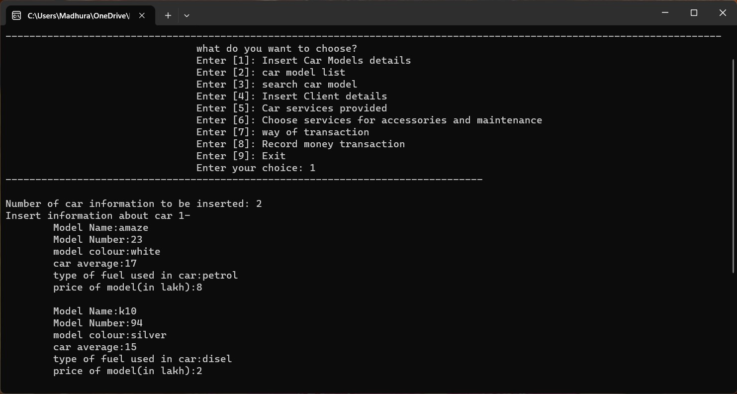

To insert the data about the car models in a file If user wants to insert data about car model details– Press 1 in a file – Press 1.Enter the number of model whose details want to insert and enter he information of model.

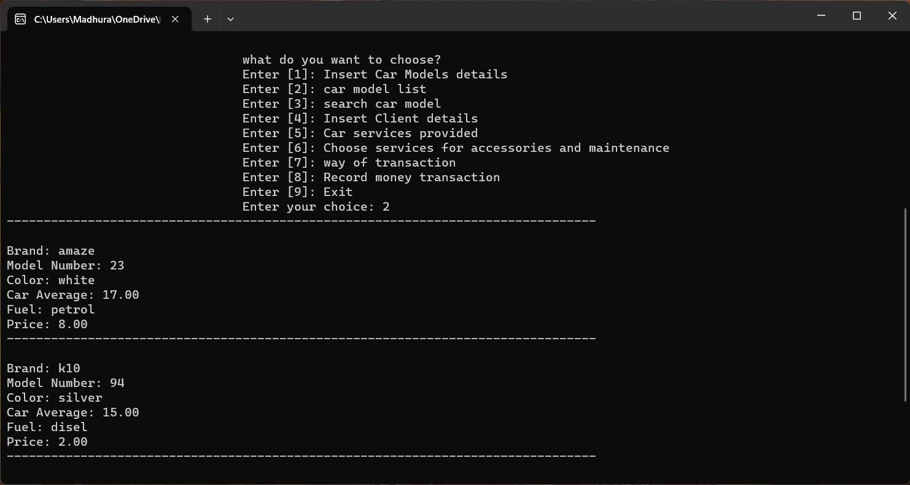

To see details about all the car model :- Press 2.User will able to see details of the all model.(brand name,model number,color of model,type of fuel used,price of model)

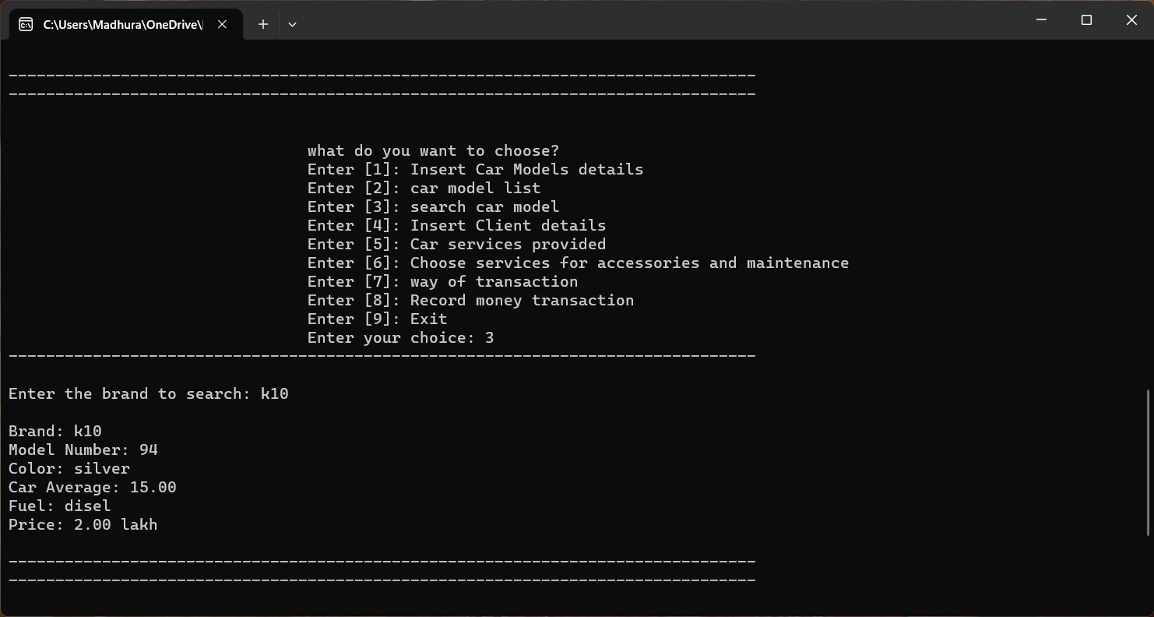

If user wants to see the details about particular car model – Press 3 and enter the car model name whose details want to know

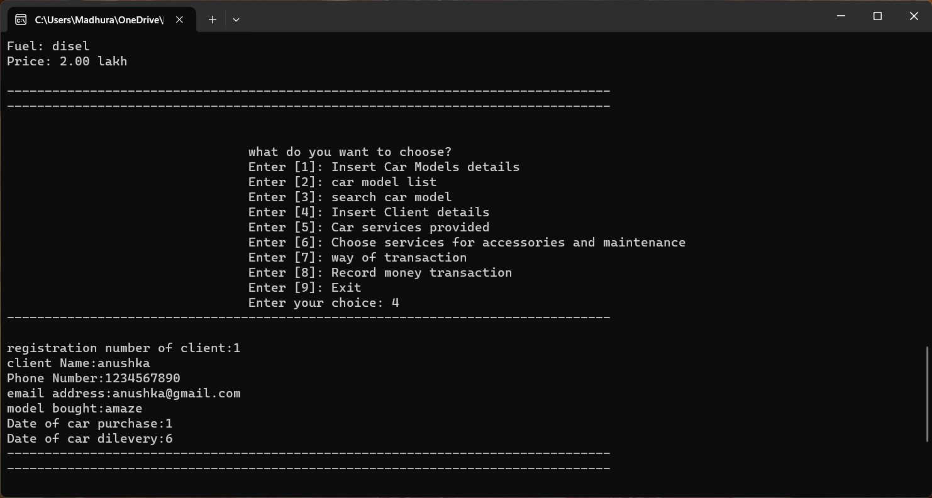If the user wants to add details of client in a file– Press 4.Enter the details of client.

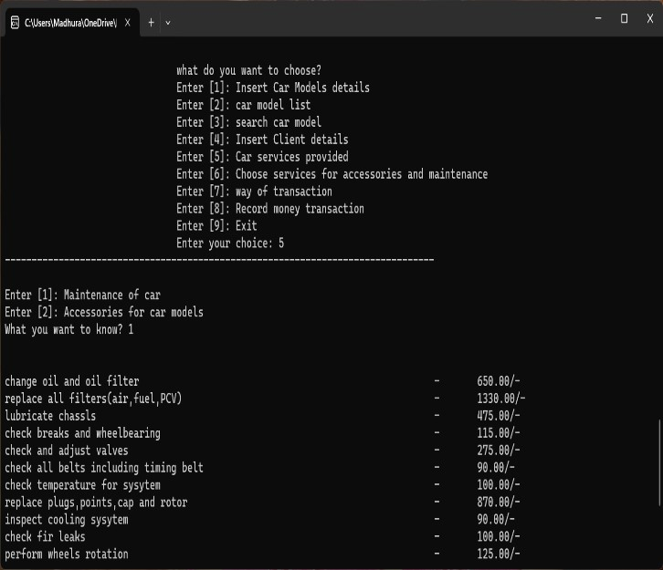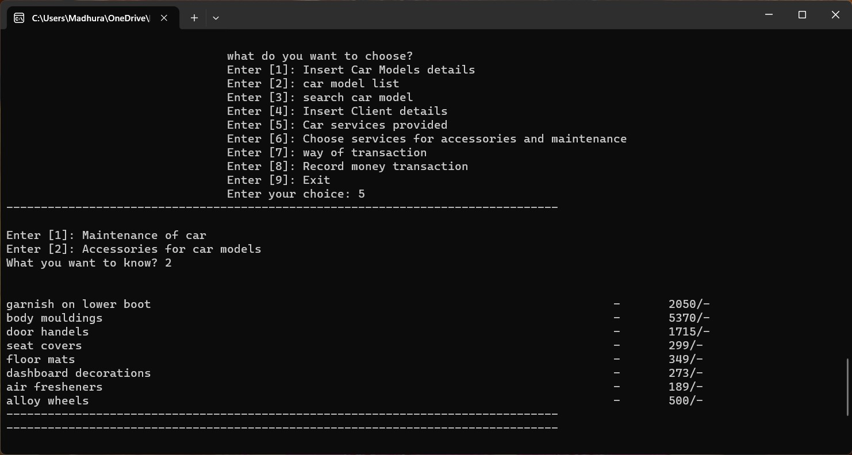

If the user wants to see the the list of service provided by the showroom – Press 5.The list will show the prices of service provided also.

i. For list of services of maintenance of car – Press 1 ii. For the accessories of the car model – Press 2

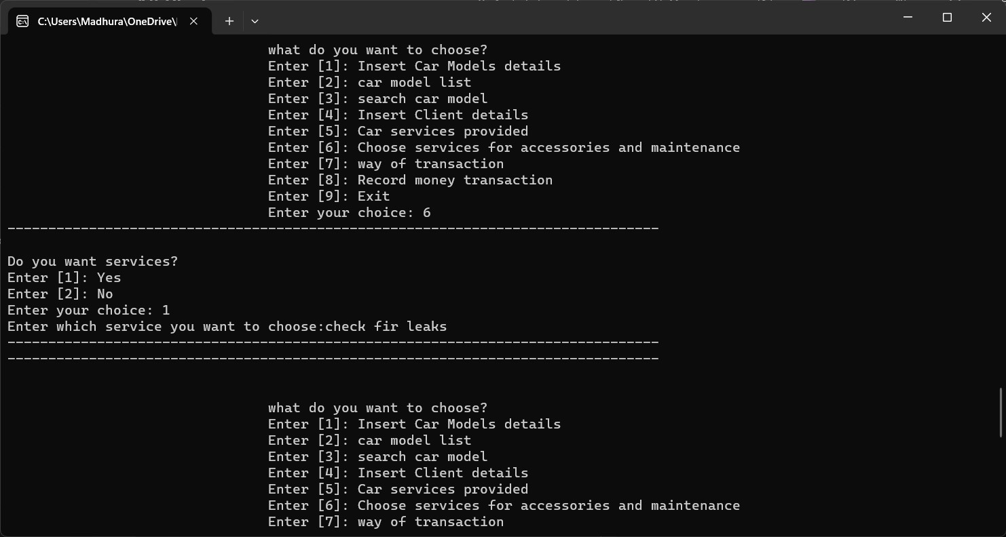

If the user wants to take services provided by showroom – press 6

i. If user wants to apply for service – Press 1 ii. If user do not wants to apply for service – Press 2

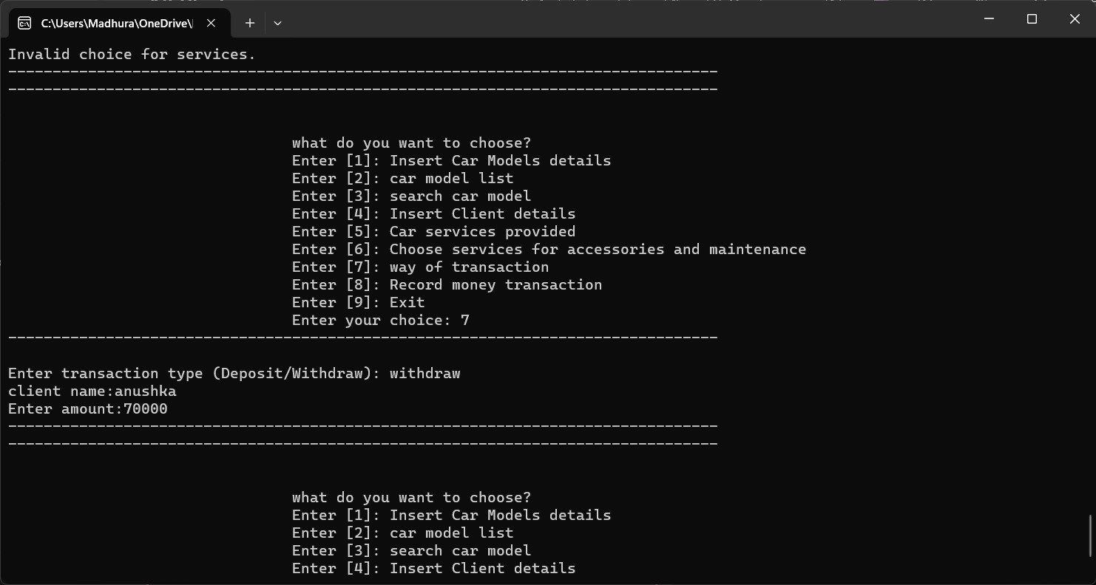

During transaction, if user wants to add transaction details like mode of transaction , amount and client name – Press 7

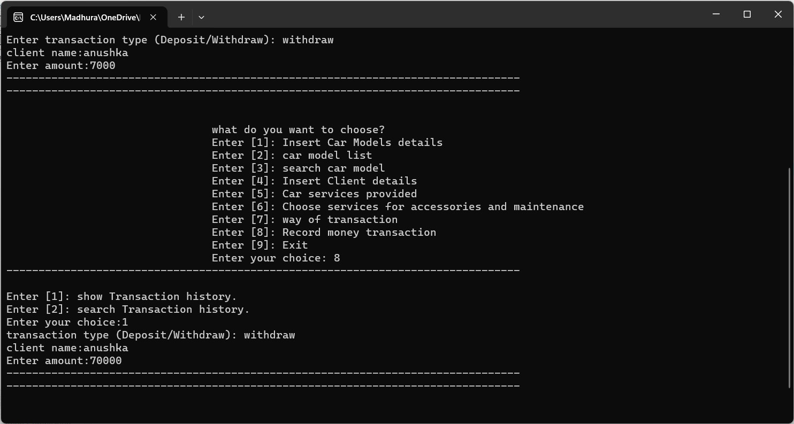

If user wants to see the transaction details of clients – press 8.

1. Transaction history till date – press 9
2. Search the about particular transaction – press 2

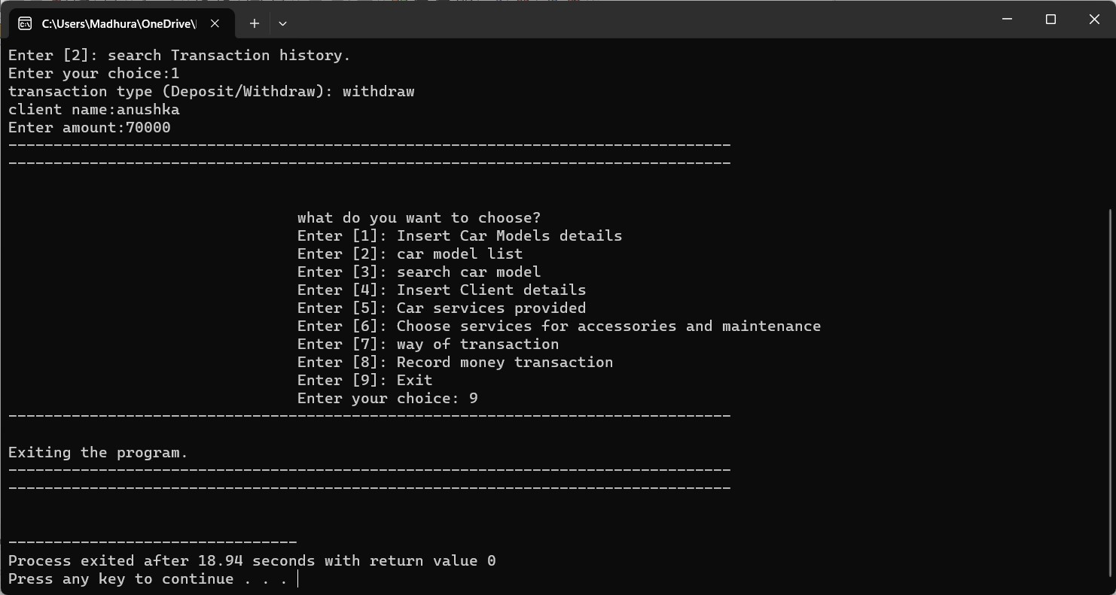

If you want to exit the program press 9.

## Data insert in file

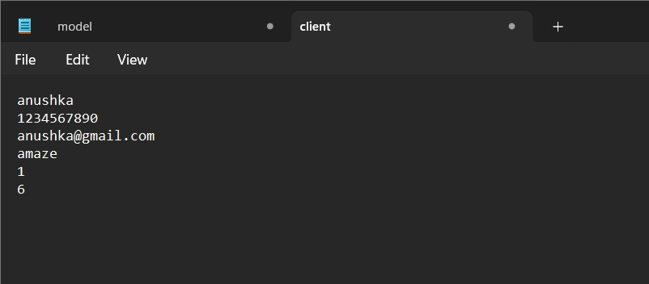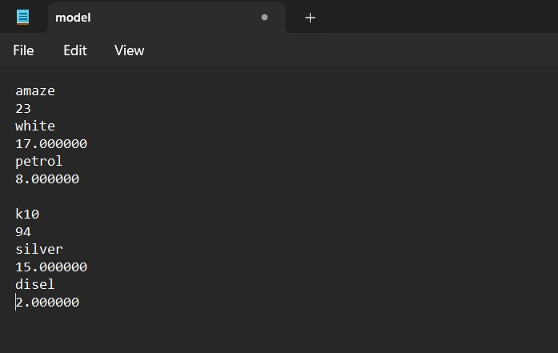

We can get the above output when the data is stored in a file.

**Conclusion:**

We have developed software for car showroom management with the basic logic.

The function .We have implemented the Standard Input Output Header Library and header general purpose standard library of functions in our software.

We have also executed the software with different input scenario and observed the output. The software performs all tasks as per expectation.

**References:**

1. <https://templatelab.com/vehicle-maintenance-log/#google_vignette>
2. <https://www.programiz.com/c-programming/c-structure-function>
3. [www.google.com](http://www.google.com/)